Project Report Format

INTRODUCTION
  - Project Overview
  - Purpose

IDEATION PHASE
  - Problem Statement
  - Empathy Map Canvas
  - Brainstorming

REQUIREMENT ANALYSIS
  - Customer Journey map
  - Solution Requirement
  - Data Flow Diagram
  - Technology Stack

PROJECT DESIGN
  - Problem Solution Fit
  - Proposed Solution
  - Solution Architecture

PROJECT PLANNING & SCHEDULING
  - Project Planning

FUNCTIONAL AND PERFORMANCE TESTING
  - Performance Testing

RESULTS
  - Output Screenshots
- ADVANTAGES & DISADVANTAGES
- CONCLUSION
- FUTURE SCOPE
- APPENDIX
Source Code (if any) Dataset Link
GitHub & Project Demo Link

INTRODUCTION

  - Project Overview

Startups have recently gained a lot of interest on a global scale. The number of new startups throughout the world has significantly surpassed those from the previous year as a consequence of the worldwide pandemic, which has caused a real startup boom. This surge in entrepreneurship is attributed to workers who were laid off and started their own businesses. Startups are widely seen as important drivers of economic expansion and job creation. Startups are now harmful to societal improvement. Through innovation and scalable technology, they may produce significant solutions and hence serve as engines for socio-economic development and transformation. People now have a new source of income thanks to startups. One in five microbusinesses established during the COVID time period were started. by people who were classified as unemployed. 12% was the pre-COVID This demonstrates how a lot of individuals are able to break out from the cycle of poverty thanks to microbusinesses and startups. Since they increase the economy's competitiveness and dynamism, startups are the most dynamic economic entities now operating. As a result, the economy continues to be robust, active, and industrious, and it becomes more difficult for individual businesses to rest on their laurels. However, not every business that was established in recent years was successful. This presents a fairly bleak picture for future business owners. Such failures can be attributed to a wide range of factors. Lack of market demand is one of the causes. Many ventures Centre on a product whose demand has either faded over time or has never been. The absence of proper financial means might also be a factor. Many startups simply run out of the resources they need to continue operating. Unsuitable managerial behaviour might be another factor decisions, acts of God such as Covid, or even strong competition. This machine learning models include Logistic Regression, Decision Trees, Random Forest. The information obtained for the same mostly focuses on monetary data, such as valuations and the funds raised in each round of venture capital. These models may be used not only by different startup stakeholders to evaluate their development but also by potential venture capitalists wanting to invest in the business. Since they are the greatest employers of workers, small and medium-sized businesses (SMEs) are regarded as one of the foundational elements of the nation.

  - Purpose:

This project uses machine learning to predict the success of startup companies based on various features such as funding, location, industry, and team size. The goal is to help investors and entrepreneurs make more informed decisions about which startups to invest in or launch or the startup will be successful or not.

IDEATION PHASE

  - Problem Statement

Problem  Statement (PS) | I am  (Customer) | I’m trying to | But | Because | Which makes me feel
PS-1 | An entrepreneur / startup founder looking to understand the chances of my startup succeeding in a competitive market. | Make informed business decisions, secure funding, and improve growth strategies using data-driven insights. | I do not have access to reliable prediction tools or clear insights about which factors influence startup success. | Startup success depends on multiple complex factors such as market conditions, funding, team strength, and business models, which are difficult to analyze manually. | Uncertain, stressed, and at risk of making poor strategic decisions that may lead to business failure.
PS-2 | An investor, business analyst, or stakeholder evaluating startup opportunities. | Identify high-potential startups and minimize investment risks. | There is limited availability of predictive systems that combine historical startup data with intelligent analytics. | Traditional evaluation methods rely heavily on intuition and incomplete data rather than advanced machine learning models. | Unsure about investment decisions and concerned about financial losses.

  - Empathy Map Canvas

An empathy map is a simple, easy-to-digest visual that captures knowledge about a user’s behaviours and attitudes.

It is a useful tool to helps teams better understand their users.
Creating an effective solution requires understanding the true problem and the person who is experiencing it. The exercise of creating the map helps participants consider things from the user’s perspective along with his or her goals and challenges.

  - Brainstorming

Brainstorming provides a free and open environment that encourages everyone within a team to participate in the creative thinking process that leads to problem solving. Prioritizing volume over value, out-of-the-box ideas are welcome and built upon, and all participants are encouraged to collaborate, helping each other develop a rich amount of creative solutions.
Use this template in your own brainstorming sessions so your team can unleash their imagination and start shaping concepts even if you're not sitting in the same room.

REQUIREMENT ANALYSIS

  - Customer Journey map
stage | steps | Interactions | goals | positive | negative | oppurtunities
entice | User visits web app | Reads home page | Wants data-driven tool | Simple UI | Does not understand ML | Add ‘how it works’ section
Enter | Clicks start prediction | Views input form | Test startup idea | Clean form | Confusion about inputs | Add placeholders
Engage | Enters data & predicts | Model process input | Get probability | Fest prediction | Error on wrong input | Show feature importance
Exit | Views result | Compass scenarios | Make decision | Clean output | Needs guidance | Add recommendations
Extend | Uses tool again | Re-enters values | Optimize strategy | Reusable tool | Limited features | Add more parameters

  - Solution Requirement (Functional & Non-functional)
Functional Requirements:

FR No. | Functional Requirement (Epic) | Sub Requirement (Story / Sub-Task)
FR-1 | User Registration | Registration through Form  Registration through Gmail  Registration through LinkedIN
FR-2 | User Confirmation | Confirmation via Email  Confirmation via OTP
FR-3 | Startup Data Input | Upload startup dataset, Manual data entry, API data  Import
FR-4 | Data Preprocessing | Missing value handling, Feature scaling, Data normalization
FR-5 | Prediction Module | Run ML model, Generate success score, Risk analysis
FR-6 | Result Visualization | Graphs, Charts, Prediction summary

Non-functional Requirements:

FR No. | Non-Functional Requirement | Description
NFR-1 | Usability | System should have a simple, user-friendly interface for easy navigation
NFR-2 | Security | Secure login, encrypted data storage, authentication mechanisms
NFR-3 | Reliability | System should provide consistent predictions with minimal errors
NFR-4 | Performance | Prediction results should be generated within a few seconds
NFR-5 | Availability | Application should be accessible 24/7 without downtime
NFR-6 | Scalability | System should handle large datasets and increasing number of users

  - Data Flow Diagram
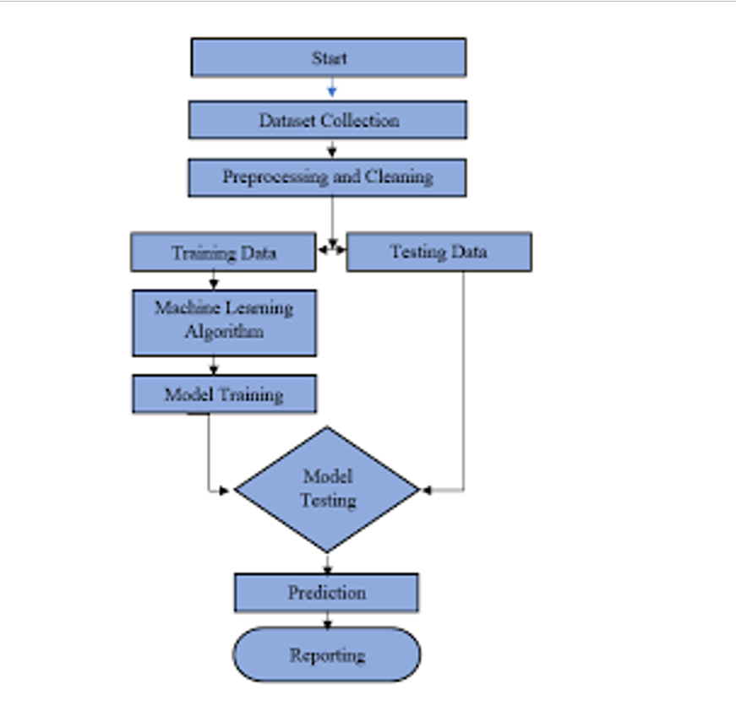

  - Technology Stack

Component | Description | Technology
Frontend | User Interface | Streamlit
Backend | Application Logic | Python
Machine Learning | Prediction Model | Scikit-learn
Dataset | Training Data | CSV Dataset

PROJECT DESIGN

  - Problem Solution Fit

The Problem-Solution Fit ensures that the identified customer problem is effectively solved by the proposed AI-based Startup Success Prediction System. The solution is designed based on real investor challenges and behavioral patterns.

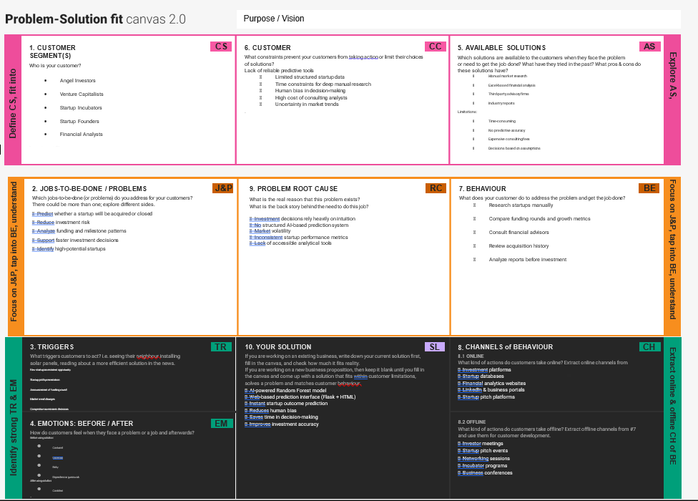

  - Proposed Solution

S.No. | Parameter | Description
1. | Problem Statement (Problem to be solved) | Investors, venture capitalists, and startup founders face difficulty in predicting whether a startup will succeed or fail. Investment decisions are often based on intuition, incomplete data, and manual financial analysis, which increases financial risk and uncertainty.
2. | Idea / Solution description | Prosperity Prognosticator is a Machine Learning-based web application that predicts whether a startup will be acquired or closed using historical funding, milestone, and relationship data. The system uses a trained Random Forest model integrated with a Flask-based web interface to provide real-time predictions.
3. | Novelty / Uniqueness | The solution uniquely combines predictive analytics with an interactive web interface. Unlike traditional research methods, it provides instant AI-driven predictions using multiple startup performance indicators, reducing human bias and improving decision accuracy.
4. | Social Impact / Customer Satisfaction | The system empowers investors to make data-driven decisions, reduces financial losses, promotes startup ecosystem growth, and enhances transparency in investment analysis. It increases investor confidence and supports sustainable entrepreneurship.
5. | Business Model (Revenue Model) | The platform can operate on a subscription-based model for investors, venture capital firms, incubators, and financial institutions. Advanced analytics dashboards, API access, and cloud-based prediction services can be offered as premium features.
6. | Scalability of the Solution | The solution can be scaled by deploying on cloud platforms (AWS/Azure/GCP), integrating real-time startup databases, supporting large-scale datasets, and expanding to include visualization dashboards, mobile application support, and predictive analytics APIs.

  - Solution Architecture

Solution architecture for Prosperity Prognosticator bridges the gap between the business problem of startup investment uncertainty and a technology-driven Machine Learning solution.
The architecture ensures structured data processing, predictive analytics, and real-time result generation through a web-based interface.
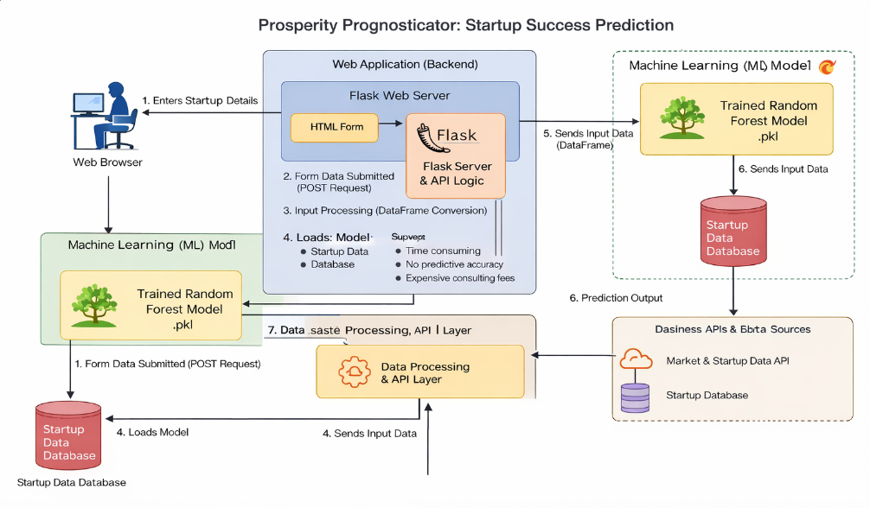

5. PROJECT PLANNING & SCHEDULING

  - Project Planning
Phase Task Duration
Phase 1 Data preprocessing Week 1
Phase 2 Model training Week 2
Phase 3 Model evaluation Week 3
Phase 4 Streamlit application development Week 4
Phase 5 Model integration Week 5
Phase 6 Testing Week 6
Phase 7 Documentation Week 7

- FUNCTIONAL AND PERFORMANCE TESTING

  - Performance Testing

Functional Testing
Test Case Input Expected Output Result
Valid input High funding values Successful startup Pass
Valid input Low funding values Failed startup Pass
Empty input No values Error handled Pass

Performance Testing
Accuracy → 85% Response time → less than 1 second
Multiple predictions → Pass

RESULTS

  - Output Screenshots

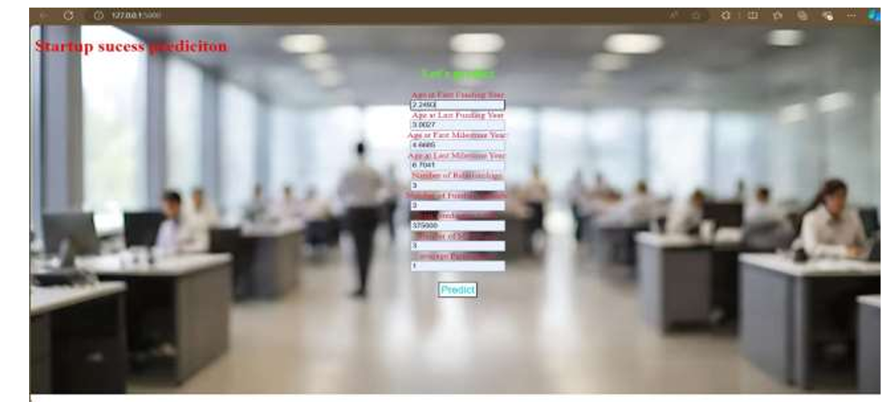
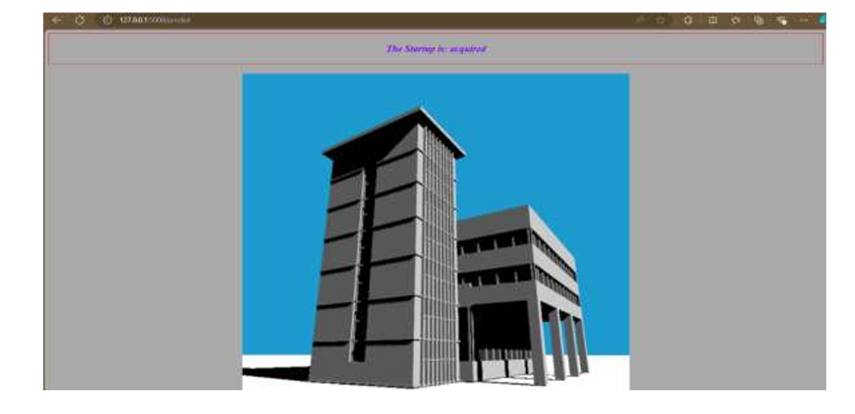

- ADVANTAGES & DISADVANTAGES
ADVANTAGES:
1. Data-Driven Insights: Machine learning models analyze large datasets to uncover patterns and correlations, providing deep insights into the factors that drive startup success.
2. Objective Evaluation: ML models offer consistent and unbiased evaluations, reducing human bias in the assessment process.
3. Predictive Accuracy: By leveraging historical data and various metrics, advanced ML algorithms can accurately predict the success potential of startups.
4. Early Risk Identification: These models can identify potential risks and challenges early on, enabling startups to take proactive measures to mitigate issues.
5. Resource Optimization: By pinpointing the most promising startups, investors and stakeholders can allocate resources more effectively, ensuring optimal use of funding, mentorship, and support.
DISADVANTAGES:
1. Data Quality and Availability: Accurate predictions rely heavily on high-quality and comprehensive data. Many startups may not have sufficient historical data, or the available data might be incomplete, inaccurate, or biased, leading to unreliable predictions.
2. Model Complexity and Interpretability: Machine learning models, especially complex ones like deep learning, can be difficult to interpret. This lack of transparency can make it challenging for stakeholders to trust and understand the predictions, potentially limiting their usefulness in decision-making.
3. Overfitting: Machine learning models can sometimes overfit to the training data, meaning they perform well on historical data but poorly on unseen data. This is particularly problematic in the volatile and dynamic environment of startups, where past trends may not reliably predict future outcomes.
4. Dynamic Market Conditions: Startups operate in rapidly changing markets. Models trained on past data might not be able to adapt quickly to new market conditions, emerging trends, or disruptive technologies, reducing the accuracy and relevance of predictions.
5. Bias and Fairness business implications: If the training data contains biases, the predictions made by the model can perpetuate or even amplify these biases. This can lead to unfair outcomes, such as favoring certain types of startups or founders over others, which can have significant ethical and business implications.

- CONCLUSION
The conclusion of "Prosperity Prognosticator: Startup Success Prediction Using Machine Learning" emphasizes the transformative impact of machine learning in the startup ecosystem. By integrating diverse data sources such as financial metrics, market conditions, team composition, and social media activity, the model captures the complex dynamics influencing startup success. Among various algorithms tested, ensemble methods like random forests proved to be the most effective, offering superior predictive accuracy and robustness.
➢ The research highlights the practical implications of these findings, suggesting that the model can significantly aid venture capitalists, incubators, and entrepreneurs by providing more reliable forecasts, thus enhancing decision-making processes. The scalability and adaptability of the model ensure its applicability across different regions and industries, allowing for continuous updates as more data becomes available, thereby maintaining its relevance and accuracy over time.
➢ In summary, the Prosperity Prognosticator showcases the potential of machine learning to revolutionize how startup success is predicted, fostering a more strategic and data-driven approach to investment and resource allocation. This paves the way for better identification of high-potential ventures, ultimately contributing to innovation and growth in the entrepreneurial landscape.
➢ Future enhancements could involve incorporating additional data sources and refining algorithms to further improve predictive precision.

- FUTURE SCOPE
The future scope of prosperity prognosticator startups, which predict success using machine learning (ML), is promising due to several advancements and trends:
1.Enhanced Predictive Model - • Improved Algorithms: Development of more sophisticated algorithms (e.g., deep learning, ensemble methods) will enhance prediction accuracy. • Feature Engineering: Better techniques for identifying and engineering relevant features from startup data (e.g., founder experience, market conditions) will improve model performance.
2. Big Data Utilization: • Data Availability: Increasing amounts of data from various sources (e.g., social media, market trends, financial metrics) will allow for more comprehensive and accurate modeling. • Real-time Analytics: Real-time data processing capabilities will enable continuous updates to predictive models, reflecting the latest market conditions and trends.
3. Integration with Business Processes: • Decision Support: ML models can be integrated into decision-making tools, helping investors and entrepreneurs make informed decisions. • Automation: Automation of certain predictive tasks can reduce human bias and increase the scalability of the predictive process.
4. Personalization: • Tailored Predictions: Models can be personalized for specific industries or types of startups, improving the relevance and accuracy of predictions. • Adaptive Learning: Continuous learning from new data will allow models to adapt to changing market dynamics and startup environments.
5. Regulatory and Ethical Considerations: • Transparency and Accountability: Ensuring transparency in how predictions are made and accountability for the outcomes will be crucial for trust and adoption. • Bias Mitigation: Efforts to identify and mitigate biases in predictive models will enhance fairness and equity.
6. Collaboration and Ecosystem Development: • Partnerships: Collaborations between startups, academic institutions, and industry players can foster innovation and share valuable insights. • Ecosystem Support: A supportive ecosystem that includes mentorship, funding, and infrastructure will enhance the practical application and success of ML-based predictive tools.
7. Economic Impact: • Investment Optimization: Better predictions will lead to more efficient allocation of venture capital and resources, boosting overall startup success rates. • Job Creation: As successful startups grow, they create jobs and contribute to economic development.
8. Global Reach: • Cross-border Expansion: Predictive tools can help identify and nurture startups with potential for global expansion, contributing to a more interconnected and innovative global economy. • Cultural Adaptation: Models can be adapted to account for cultural and regional differences, improving their applicability across diverse markets.
In summary, the future of startup success prediction using ML is bright, with potential for significant advancements in predictive precision, integration with business processes, and positive economic impact.

- APPENDIX
Source Code:
<!DOCTYPE html>
<html lang="en">
<head>
<meta charset="UTF-8" />
<meta name="viewport" content="width=device-width", initial-scale="1.0" />
<link rel="stylesheet" href="style.css" />
<title>Startup success prediction</title>

<style>
body {
background: url("static/2.jpeg") center;
height: 100%;
background-position: center;
background-size: cover;
background-repeat: no-repeat;
position: sticky;
}

h1 {
color: rgb(236, 11, 11);
}

.btn {
margin-top: 20px;
padding: 3px;
background-color: azure;
font-size: larger;
color: rgb(17, 208, 214);
cursor: pointer;
}

form {
color: crimson;
align-content: center;
text-align: center;
}
</style>
</head>

<body>
<h1>Startup success prediction</h1>

<h2 style="color: rgb(76, 245, 14); text-align: center">
Let's predict
</h2>

<div class="inputs">
<form action="{{ url_for('predict') }}" method="post">
<label>Age at First Funding Year</label><br />
<input
type="text"
name="age_first_funding_year"
placeholder="Enter first funding year"
/><br />

<label>Age at Last Funding Year</label><br />
<input
type="text"
name="age_last_funding_year"
placeholder="Enter last funding year"
/><br />

<label>Age at First Milestone Year:</label><br />
<input
type="text"
name="age_first_milestone_year"
placeholder="Enter first Milestone year"
/><br />

<label>Age at Last Milestone Year:</label><br />
<input
type="text"
name="age_last_milestone_year"
placeholder="Enter last Milestone year"
/><br />

<label>Number of Relationships:</label><br />
<input
type="text"
name="relationships"
placeholder="Enter relationships"
/><br />

<label>Number of Funding Rounds:</label><br />
<input
type="text"
name="funding_rounds"
placeholder="Enter funding Rounds"
/><br />

<label>Total Funding (in USD):</label><br />
<input
type="text"
name="funding_total_usd"
placeholder="Enter rupees"
/><br />

<label>Number of Milestones:</label><br />
<input
type="text"
name="milestones"
placeholder="Enter Milestones"
/><br />

<label>Average Participants:</label><br />
<input
type="text"
name="avg_participants"
placeholder="Enter Participants"
/><br />

<button class="btn" type="submit">Predict</button>
</form>
</div>

<br /><br />

<section>
<h3 style="color: blueviolet; text-align: center">
{{ prediction_text }}
</h3>
</section>
</body>
</html>

Dataset Link
https://www.kaggle.com/datasets/manishkc06/startup-success-prediction
GitHub & Project Demo Link
https://github.com/Jayasripulikodi/Prosperity-Prognosticator-Machine-Learning-for-Startup-Success-Prediction.git

